University Of Engineering and Technology, Lahore
Computer Engineering Department

Course Name: Programming Fundamental | Course Code: CMPE-112L
Assignment Type: Lab Report | Dated:
Semester: 1st | Session: 2026 Spring
Lab/Project/Assignment #: 1 | CLOs to be covered: CLO
Lab Title: Input/Output, Data type, Operator, If-Else | Teacher Name: Hafiz Muhammad Mubashar
Lab Evaluation:

CLO1 | Apply appropriate programming techniques to create executable programs to solve well defined problems
 | Level1 | Level2 | Level3 | Level4 | Level5 | Level6
(5)
Total |  |  |  |  |  | /5
Rubrics for Current Lab Evaluation
Scale | Marks | Level | Rubric
Excellent | 5 | L1 | Submitted all lab tasks, BONUS task, have good understanding.
Very Good | 4 | L2 | Submitted the lab tasks but have good understanding
Good | 3 | L3 | Submitted the lab tasks but have weak understanding.
Basic | 2 | L4 | Submitted the lab tasks but have no understanding.
Barely Acceptable | 1 | L5 | Submitted only one lab task.
Not Acceptable | 0 | L6 | Did not attempt
LAB No 1
Lab Goals/Objectives:

To understand the basics of Python programming.

Equipment Required:

• Computer/Laptop
• Python 3.x
• IDE (IDLE, VS Code, or PyCharm)

Theory:

Python is a simple, high-level programming language. It uses input() for user input and print() for output. Python supports data types such as int, float, str, and bool. Operators perform arithmetic, comparison, logical, and assignment operations. Conditional statements (if, if-else, and if-elif-else) are used to make decisions based on conditions.

Lab Work:
Input/Output:

Task 1:
print("Zainab")
print("76")
print("17")
Result:
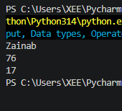

Task 2:

print(" * ")
print(" * * ")
print(" * *")
print("* * * * * ")

Result:

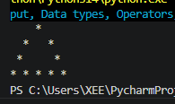

Task 3:

celsius = float(input("Enter temperature in Celsius: "))
fahrenheit = (celsius * 9/5) + 32
print(celsius, "=", fahrenheit)

Result:

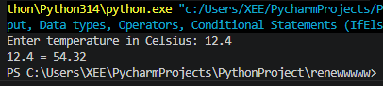

Task 4:

Name = input("enter your name")
Age = input("enter your age")
Roll = input(" enter your roll no")
print(Name)
print(Age)
print(Roll)

Result:

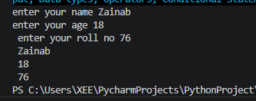

Task 5:
bytes = float(input("Enter the number of bytes: "))
megabytes = bytes / (1024 * 1024)
gigabytes = bytes / (1024 * 1024 * 1024)
print("Megabytes (MB):", megabytes)
print("Gigabytes (GB):", gigabytes)

Result:
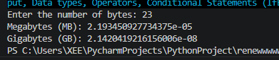

Task 6:

ecat_marks = float(input("Enter your ECAT percentage: "))
inter_marks = float(input("Enter your Intermediate Part-I percentage: "))
matric_marks = float(input("Enter your Matric percentage: "))
aggregate = (ecat_marks * 0.33) + (inter_marks * 0.50) + (matric_marks * 0.17)
print("Your Aggregate is:", round(aggregate, 2), "%")

Result:

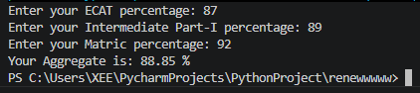

Data Types:

Task 1:

age = 20
print(age)
print(type(age))

Result:

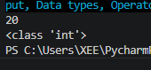

Task 2:
Price = 12.4
print(Price)
print(type(Price))

Result:

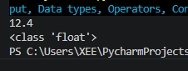

Task 3:

name = "zainab"
print(name)
print(type(name))

Result:

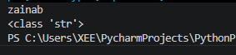

Task 4:

marks = True
print(marks)
print(type(marks))

Result:

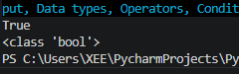

Operators:

Task 1:
a=(int("1"))
b=(int("2"))
c=a+b
print(c)

Result:

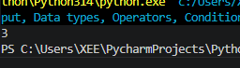

Task 2:
a=("1")
b=("2")
c=a+b
print(c)

Result:

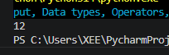

Task 3:

celsius = float(input("Enter temperature in Celsius: "))
fahrenheit = (celsius * 9/5) + 32
print(celsius, "=", fahrenheit)

Result:

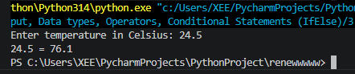

Task 4:

a=int("5")
b=int("6")
print(a+b)

print(int(3.1))
print(float(3))

Result:

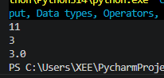

Conditional statement:

Task 1:

a=int(input("enter obtained marks"))
b=int(input("enter total marks"))
c=a/b*100
print(c)
if c>=90:
print("A")
elif c>=85:
print("A-")
elif c>=80:
print("B+")
elif c>=75:
print("B-")
elif c>=70:
print("C+")
elif c>=65:
print("C-")
elif c>=60:
print("D+")
elif c>=55:
print("D-")
elif c<=50:
print("F")

Result:

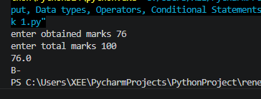

Task 2:

import math
import cmath # Used for imaginary roots

a = float(input("Enter value of a: "))
b = float(input("Enter value of b: "))
c = float(input("Enter value of c: "))

D = b**2 - 4*a*c

print("Discriminant =", D)
if D == 0:
print("Roots are real, equal and rational.")

root1 = (-b + math.sqrt(D)) / (2*a)
root2 = (-b - math.sqrt(D)) / (2*a)

elif D > 0:
print("Roots are real, distinct and irrational.")

root1 = (-b + math.sqrt(D)) / (2*a)
root2 = (-b - math.sqrt(D)) / (2*a)

else:
print("Roots are imaginary.")

root1 = (-b + cmath.sqrt(D)) / (2*a)
root2 = (-b - cmath.sqrt(D)) / (2*a)

print("Root 1 =", root1)
print("Root 2 =", root2)

Result:

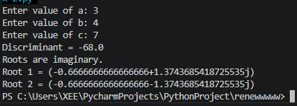

Task 3:
num = input("Enter a number: ")

if num == num[::-1]:
print(num, "is a Palindrome Number")
else:
print(num, "is Not a Palindrome Number")

Result:

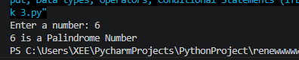

Task 4:
import math
x1 = float(input("Enter x1: "))
y1 = float(input("Enter y1: "))

x2 = float(input("Enter x2: "))
y2 = float(input("Enter y2: "))

def find_quadrant(x, y):
if x > 0 and y > 0:
return "First Quadrant"
elif x < 0 and y > 0:
return "Second Quadrant"
elif x < 0 and y < 0:
return "Third Quadrant"
elif x > 0 and y < 0:
return "Fourth Quadrant"
elif x == 0 and y == 0:
return "Origin"
elif x == 0:
return "On Y-Axis"
else:
return "On X-Axis"

q1 = find_quadrant(x1, y1)
q2 = find_quadrant(x2, y2)

distance = math.sqrt((x2 - x1)**2 + (y2 - y1)**2)
print("Point 1 lies in:", q1)
print("Point 2 lies in:", q2)
print("Distance between points =", round(distance, 2))

Result:

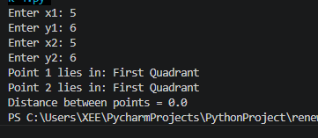

Conclusion:
In this lab, we learned the basics of Python programming, including input/output, data types, operators, and conditional statements. These concepts provide the foundation for writing simple and logical Python programs.

